Lab Manual for Object-Oriented Programming
(LAB-07)

Reusability II
(The protected Access Specifier and Types of Inheritance)

Table of Contents
1. Introduction 82
2. Activity Time Boxing 83
3. Objective of the Experiment 83
4. Concept Map 83
5. Homework before Lab 84
5.1 Problem Solution Modeling 84
5.2 Practices from Home 84
6. Procedure & Tools 85
6.1 Tools 85
6.2 Setting-up Visual Studio 2008 [Expected time = 5 mins] 85
6.3 Walkthrough Task [Expected time = 30 mins] 85
7. Practice Tasks 86
7.1 Practice Task 1 [Expected Time = 25 mins] 86
7.2 Practice Task 2 [Expected Time = 25 mins] 87
7.3 Practice Task 3 [Expected Time = 35 mins] 87
7.4 Outcomes 87
7.5 Testing 87
8. Evaluation Task (Unseen) [Expected Time = 50 mins for all tasks] 88
9. Evaluation Criteria 88
10. Further Reading 88
10.1 Books 88
10.2 Slides 88

Lab 09: The protected Access Specifier and Types of Inheritance in C++

Introduction
So far, you have learned the importance and use of two (public and private) access specifiers within class(es) of C++. You know that a class’s member functions are able to access class’s data fields having public or private accessibility for all times. However, externally created object(s) can only access public data members of that class and private data members are restricted to be accessed outside the class. For example, consider the following class:

class Examp
{
private:
int attribute;
public:
void show()
{
cout<<attribute;
}
};

Any externally created instance (e.g. Obj) of class Examp would not be able to access data member(s) directly while using the dot (.) operator. Hence, in the main() function, the statement Obj.attribute is not legal but the statement Obj.show() is legal.

It is sufficient to know about public and private access specifiers/modifiers in the absence of inheritance. However, in case of inheritance, sometimes it is required to access data member(s) of base class in derived class(es) but not outside these classes. In this situation, you must make access protected for that data member(s) rather than private or public. Protected access will ensure access of data members only within inheritance hierarchy.

Another important use of access specifiers is their role in the inheritance process. Considering access specification in C++, inheritance can be private, protected, or public. Each type of inheritance has specific rules to access base class’s data member(s), which have been explained below.

Public Inheritance:
Syntax: class Student: public Person { };

If a class is derived from a base class with public specifier, then all public/protected member(s) of base class become public/protected member(s) of derived class. However, private member(s) of base class are never accessible from derived class directly.

Protected Inheritance:
Syntax: class Student: protected Person { };

If a class is derived from a base class with protected specifier, then all public/protected member(s) of base class become protected member(s) of derived class. However, private member(s) of base class are never accessible from derived class directly.

Private Inheritance:
Syntax: class Student: private Person { };

If a class is derived from a base class with private specifier, then all public/protected member(s) of base class become private member(s) of derived class.
Relevant Lecture Readings:
- Lectures: 17, 18
- Textbook: Object-Oriented Programming Using C++, Fourth edition, Robert Lafore.
  - Pages: 372 - 428

Activity Time Boxing
Table 1: Activity Time Boxing

Task No. | Activity Name | Activity time | Total Time
6.2 | Setting-up Visual Studio | 5 mins | 5 mins
6.3 | Walk-through Tasks | 30 mins | 30 mins
7 | Practice tasks | 25 mins for task 1 and 2  35 mins for task 3 | 85 mins
8 | Evaluation Task | 50 min for all assigned task | 50 mins
 |  | Total Time | 170 mins

Objective of the Experiment
After completing this lab, the student should be able to:
- get basic understanding of inheritance in OOP
- develop a derived class from a base class through inheritance
- understand the use of protected access specifier with class’s data members
- understand public, private, and protected types of inheritance

Concept Map
Inheritance is one of the most important building blocks of OOP. The concept of reusable classes is helpful to manage objects. You can create new classes (derived classes) that are able to inherit certain attributes and behavior of their ancestor or base class(es). Prior to working with inheritance, it was important to consider that data member(s) should have private access and only through public member functions, you can access data members of a class. However, with inheritance, it is sometimes required to have an intermediate level of accessibility to class’s data member(s) that exists only within inheritance class hierarchy but not outside these classes.

C++ provides intermediate level of accessibility through protected access specifier. Data member(s) of a base class with protected accessibility are only be directly accessible within base class and all of its derived classes but not in other parts of the program. Nevertheless, you should be careful while making data field(s) protected. Use protected access only where you think that derived classes will use base class data field(s). The access of protected data members in the derived classes make them less secure than private data members.

Moreover, access specifiers also play their role in the inheritance process. Considering access specification in C++, inheritance can be private, protected, or public. The effects of access specifiers in inheritance process on derived class’s member(s) are different as illustrated in Table 2.

Table 2: Inheritance access specifiers and their effect on derived class members

 |  | Access Specifier with Inherited class
 |  | Private | Protected | Public
Access Specifier with Data Member in Base class | Private | Inaccessible | Inaccessible | Inaccessible
Access Specifier with Data Member in Base class | Protected | private | Protected | protected
Access Specifier with Data Member in Base class | Public | private | Private | Private

Homework before Lab

Problem Solution Modeling
Draw UML class diagrams of the following task. You are required to bring this design with you and submit to your lab instructor.

5.1.1 Problem description:

Design a class named Rectangle that includes
- data members for the length and width of a rectangle,
- respective mutator and accessor functions to set and get values of length and width, and
- a member function named recArea() to compute the area of rectangle (length x width)

From the Rectangle class, derive a class named Cuboid that contains
- a data field named height in addition to length and width,
- two functions named setHeight and getHeight() to set and get value of height data field, and
- a member function named cuboidArea() to calculate the area of a cuboid (length x width x height)
Draw UML diagram for each class and show inheritance relationship between these classes.

Practices from Home
5.2.1 Task-1

Consider a class named GraduateCourse that includes
- Three data members i.e.
  - courseID (e.g. CS2133),
  - courseName (e.g. OOP),
  - creditHours (e.g. 3 or 4), and
  - courseFee (e.g. Rs. 10,000).
- A parameterized constructor to initialize data members with values specified by the user

Derive a class named ResearchCourse from Course class, which contains
- An additional data field named experimentFee
- A parameterized constructor to initialize its own data member along with data members of the base class inherited in derived class
- ResearchCourse class also contains a member function named setExperimentFee to modify the value of its own data field
- A function named display to show the values of its own attribute along with the attributes of its base class
- A function named totalFee to display the value of aggregated fee (course fee + experiment fee) for a particular course object

Implement both classes and in the main() function, create an instance of ResearchCourse class. Invoke appropriate functions to display all attribute values as well as the total fee for this particular instance.

5.2.2 Task-2

Representing a point in the plane, a class named PlanePoint has
- Two data members i.e. X and Y (correspond to x and y coordinates) of integer type,
- Two accessor functions named as getX() and getY() to get values of data members X and Y
- A function named planeDistance() that calculates and returns the distance between two points in a plane

Derive a class named SpacePoint to imagine a point in a three-dimensional space and has following additional features:
- A data member Z of type integer to represent the z-coordinate of a point in space
- A no-argument constructor that constructs a point with coordinates (0,0,0)
- A constructor with three arguments that constructs a point with three specified coordinate values
- An accessor function, which returns the value of data field Z
- A function named spaceDistance to return the distance between two points in the space

Implement both the classes and in the main() create two points with different dimensions and invoke appropriate function to display the distance between these two points.

Procedure & Tools

Tools
Visual Studio 2008.

Setting-up Visual Studio 2008 [Expected time = 5 mins]
Setup visual studio and make a project named “InheritanceSpecifier”

Walkthrough Task [Expected time = 30 mins]
In this task, you are required to write a C++ code which would elaborate protected access specifier concept. The following lines show the output of basic Inheritance concept with protected data fields:

6.3.1 Writing Code
In the source file, which is created in the project “InheritanceSpecifier” write following C++ code:
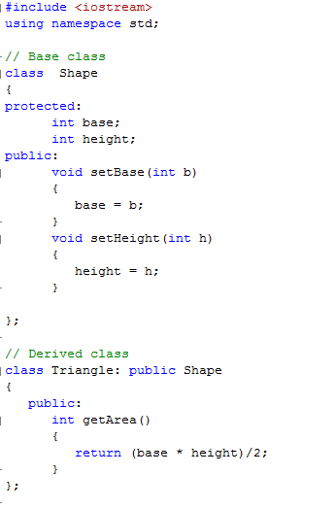
Figure 1: Base and Derived Classes
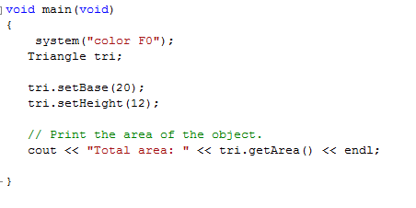
Figure 2: Main function for Figure 1
6.3.2 Compilation
After writing the code, compile your code according to the guidelines mentioned. Remove any errors and warnings that are present in your code.
6.3.3 Executing the Program
A sample output after running the program is shown below. Also run the code with other possible inputs.

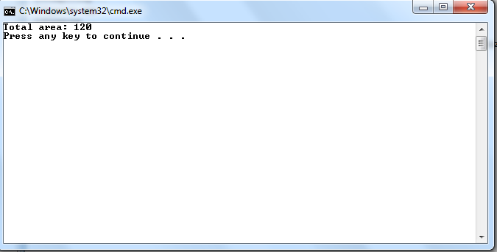
Figure 3: Final Output

Practice Tasks
This section will provide more practice exercises which you need to finish during the lab. You need to finish the tasks in the required time. When you finish them, put these tasks in the following folder:
\\dataserver\assignments$\OOP\Lab07

Practice Task 1 [Expected Time = 25 mins]
Create a class Car, which contains
- Three data members i.e. carName (of string type), ignition (of bool type), and currentSpeed (of integer type)
- A no-argument constructor to initialize all data members with default values
- A parameterized constructor to initialize all data members with user-defined values
- Three setter functions to set values for all data members individually
- Three getter function to get value of all data members individually
- A member function setSpeed( ) // takes integer argument for setting speed

Derive a class named Convertible that contains
- A data member top (of Boolean type)
- A no-argument constructor to assign default value as “false” to top
- A four argument constructor to assign values to all data-members i.e. carName, ignition, currentSpeed and top.
- A setter to set the top data member up
- A function named show() that displays all data member values of invoking object

Write a main() function that instantiates objects of Convertible class and test the functionality of all its member functions.

Practice Task 2 [Expected Time = 25 mins]
Company is the base class that holds
- Data fields named companyID (of integer type), and companyName (of string type).
- A two-argument constructor to initialize data-fields with user-defined values
- Appropriate accessor and mutator functions to set and get values of data fields

Derive two classes from the Company class:
- MobilePhone, which contains an attribute mobiulePhoneName of string type, mobileID of integer type, mobilePrice of integer type and setters and getters member function of all data members
- Laptop which contains an string variable named laptopName along with a member function to set laptop name
- Both derived classes have function display to show all data field values (including values inherited from the base class).

In the main() function, create objects of MobilePhone and Laptop classes and show the advantages of using protected access specifier.

Practice Task 3 [Expected Time = 35 mins]

A class named CafeService contains
- Two data members i.e. the orderID and the price of food item(s) served by
- A no-argument constructor to initialize both data fields with default values of “ord#0”, 0.0
- A parameterized constructor to initialize all data fields with user-defined values

Derive a class named StaffService from the class CafeService that holds the following:
- Two data members i.e.
  - serviceFee,
  - the cabinNumber to which the service has been made

- A function named totalCharges that returns total cost of an order (including serviceFee + price of food item(s) served)
- A parameterized constructor, which requires arguments for all of its own data fields as well as for the data fields of base class
- A member function named display() to show all the details of an order including orderID, price, and totalCharges

In the main() function, instantiate an object of class StaffService object and test the implementation of both classes through this object.

Outcomes
After completing this lab, student will be able to understand the implementation and design of inheritance as well as the use of protected access specifier in inheriting classes.

Testing

For all Practice Tasks, lab instructor must examine
- the implementation of all mentioned classes
- the creation of instances of specified classes
- the invocation of specified functions

Table 3: Practice Tasks Confirmation

Practice Tasks | Confirmation | Comments
T1
T2
T3

Evaluation Task (Unseen) [Expected Time = 50 mins for all tasks]

The lab instructor will give you unseen task depending upon the progress of the class.

Evaluation Criteria
The evaluation criteria for this lab will be based on the completion of the following tasks. Each task is assigned the marks percentage which will be evaluated by the instructor in the lab whether the student has finished the complete/partial task(s).

Table 4: Evaluation of the Lab

Sr. No. | Task No | Description | Marks
1 | 6 | Procedures and Tools | 10
2 | 7.1 | Practice tasks and Testing | 55
3 | 8 | Evaluation Tasks (Unseen) | 20
4 |  | Comments | 5
5 |  | Good Programming Practices | 10
 |  | Total Marks | 100

Further Reading

Books
- Object-Oriented Programming Using C++; Joyce Farrell, Fourth Edition

Slides
The slides and reading material can be accessed from the folder of the class instructor available at \\dataserver\jinnah$\

